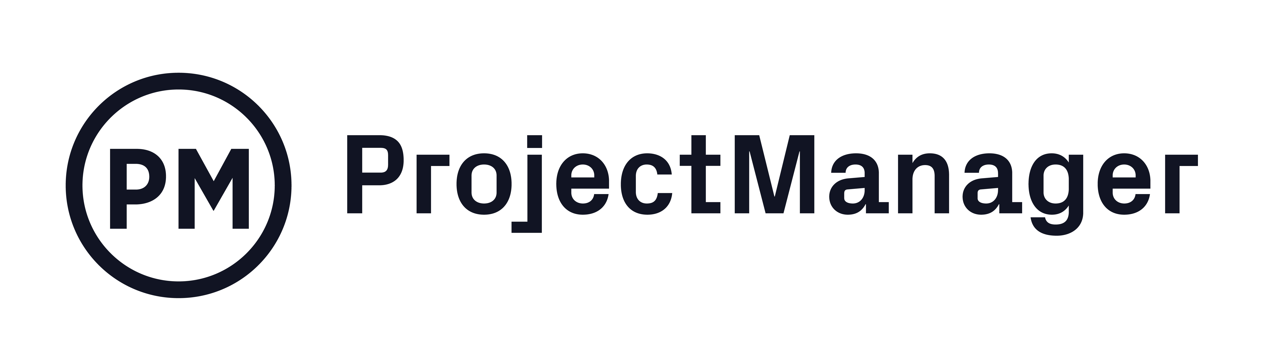

Marketing Plan
Template

Document Control

Document Information
© | Information
Document Id | [Document Management System #]
Document Owner | [Owner Name]
Issue Date | [Date]
Last Saved Date | [Date]
File Name | [Name]

Document History
Version | Issue Date | Changes
[1.0] | [Date] | [Section, Page(s) and Text Revised]

Document Approvals
Role | Name | Signature© | Date
Client

CMO

Creative Director

Other
(if applicable)

Other
(if applicable)

Other
(if applicable)

Other
(if applicable)

Table of Contents

Document Control i
Template Guide ii
1 Planning Basis 1
1.1 Business Information 1
1.2 Marketing Goals 1
1.3 Competitve Analysis & SWOT 1
1.4 Target Market 1
1.5 Buyer Cycle 2
1.6 Unique Selling Proposition 2
1.7 Marketing Strategy & Tactics 2
2 Marketing Plan 2
2.1 Brand Strategy 2
2.2 Website 2
2.3 Marketing Channels 2
2.4 SEO 2
2.5 Measurements & KPIs 2
2.6 Schedule 3
2.7 Assumptions & Constraints 3
3 Appendix 3

Template Guide

What is a Marketing Plan?

The Marketing Plan is the central document by which the marketing campaign is formally managed. A Marketing Plan is a document which lists the activities, tasks and resources required to execute the marketing push and realise the business benefits outlined by the client. A typical Marketing Plan includes:

- Business information
- Marketing goals
- Competitive analysis
- SWOT (strengths, weaknesses, opportunities and threats) analysis
- Target market
- Buyer’s cycle
- Unique selling proposition
- Brand
- Website
- Marketing channels
- SEO
- Measurements and KPIs
- Marketing strategy and tactics
- A schedule of the activities, tasks, durations, dependencies, resources and timeframes
- A listing of the assumptions and constraints identified during the planning process.

When to use a Marketing Plan

Although a summarised Marketing Plan is identified early in process, the details aren’t filled in until the scope has been formally defined and the team appointed. The Marketing Plan is completed early in the Planning Phase. The Marketing Plan is referenced constantly throughout the campaign. As the campaign is undertaken, the Manager tracks the percentage of task completion and the task completion date (actual vs planned) to assess overall performance. These statistics are communicated to the Sponsor/Client within a regular Status Report.

How to use this template

This document provides a guide on the topics usually included in a Marketing Plan. Sections may be added, removed or redefined at your leisure to meet your particular business circumstance. Example tables have been added (where suitable) to provide further guidance on how to complete each relevant section.

Planning Basis

Business Information
Write the strategy that the company will use to market its product. This is a high-level statement. The details will be listed in the following steps.

Marketing Goals
Marketing goals are the specific objectives in your marketing plan, including tasks, quotas, improvements in KPIs, etc. Some examples are listed below.

- Client approval of marketing plan
- Execution of marketing plan
- Approval of marketing materials
- Distribution of marketing materials

List and describe the marketing goals within the following table:

Goals | Description | Target Date
Client approval of marketing plan | The marketing plan has been documented and was approved by the client. | xx/yy/zz

Competitive Analysis & SWOT
List the strengths and weaknesses of the competitors who are currently in the market and those who potentially could become competitors. This helps you identify opportunities and threats when marketing your product or service. Use the SWOT (strengths, weaknesses, opportunities, threats) analysis table below for each competitor.

Strength | Weakness | Opportunity © | Threat
Large market penetration | Product could be better | Develop product that better meets customer needs | Cost of penetrating market

Target Market
The target market is the customer base you’re directing your marketing to. You should look at your current customer base, look at your competitor’s customer base, analyze your product or service, define the best demographic for your product or service, etc.

Buyer Cycle
The buyer cycle is the process that a customer goes through when they’re purchasing a product or service. It is usually defined by five major stages: awareness, consideration, intent, purchase, repurchase.

Unique Selling Proposition
The unique selling proposition is how your product or service is better than what else is available on the market. It’s a way to differentiate yourself from the competition. Come up with one that is assertive but defensible, and focus on the value it provides your customers. It’s more than just a pithy slogan.

Marketing Strategy and Tactics
The marketing strategy is your high-level plan, while the tactics are the actions you’re going to take to implement it.

Marketing Plan

Brand Strategy
Define your brand as it stands in the market. Determine how you’ll convey it in your marketing materials, and how it will be used to promote the product or service you’re marketing.

Website
Determine how your website will help market your product or service, whether that’s using the site you have or developing a new one.

Marketing Channels
Explore the various channels or routes that are best for reaching the customer. Find the ideal way to expose your product or service to the target audience.

SEO
SEO (search engine optimization) is how you can create marketing materials that will show up high in an online search using targeted keywords.

Measurements and KPIs
Develop metrics to measure the success of your marketing plan when it is being executed. Some of these KPIs (key performance indicators) including the following:

- Sales revenue
- Cost associated per lead acquisitions
- Customer lifetime value
- Online marketing ROI
- Site traffic
- Conversion rates

Schedule
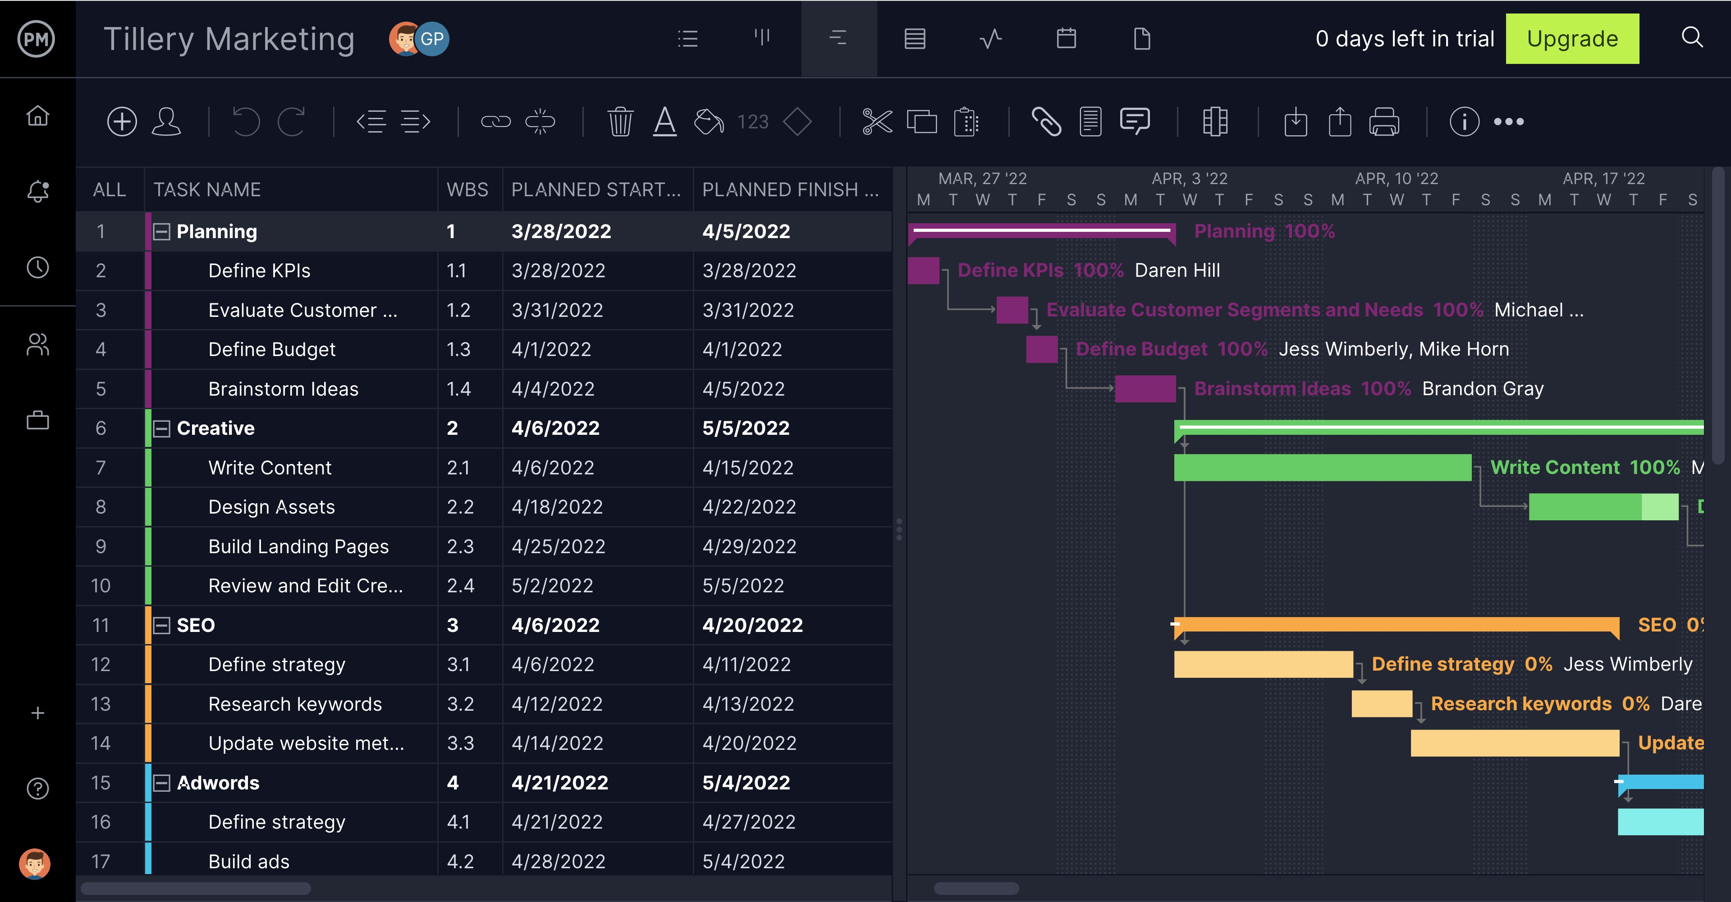

Provide a summarised schedule for each of the actions within the campaign. The best way to create your schedule, link dependencies and set milestones is with project management software.

ProjectManager has an interactive Gantt chart that can upload a task list in a spreadsheet, or you can use one of the many industry-specific templates to get started. ProjectManager’s Gantt goes further to save your plan, so you can monitor your actual progress to make sure you’re staying on track—all done in real time. You can even track multiple campaigns on the roadmap feature.

Assumptions & Constraints
List any planning assumptions made. For example:

It is assumed that:
- The campaign will not change in scope
- The resources identified will be available upon request
- Approved funding will be available upon request.

List any planning constraints identified. For example:
- The campaign must operate within the funding and resource allocations approved
- The campaign team must deliver the software with no requirement for additional hardware
- Staff must complete the campaign within normal working hours.

Appendix

Attach any documentation you believe is relevant to the marketing plan. For example:
- Detailed Schedule (listing all phases, activities and tasks)
- Other documentation
- Other relevant information or correspondence.

