Company | Company Name Here
Project | Project Name Here
Preparer | Name of Person Who Prepared Executive Summary
Contact | Address, Phone, Email of Preparer

Executive Summary

[Short description of the project vision and mission statement]

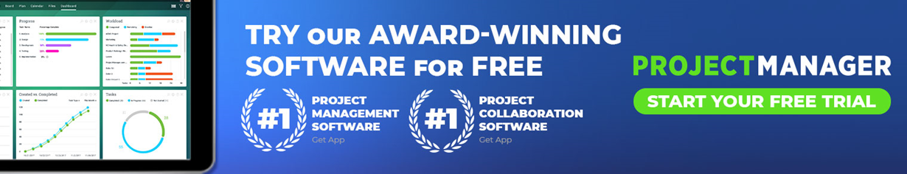
Introduction
Engage audience and briefly explain the investment opportunity and your response.

Company’s Role and Strength
Show why you’re the right team to take on the project.

Need/Problem
What is the issue, need or problem being addressed, who is the target audience and why?

Unique Solution
What is the value proposition and customer benefit, and how is your solution different from others?

Proof
Evidence, research and other facts to support how your company can solve the issue.

Resources
Outline resources needed for the project: materials, hardware, software, equipment, teams, sites, etc.
Return on Investment
Justify the project, explain its profitability and why your company is uniquely qualified to lead it.

Competition
Who is competing for the same opportunity, and how do you differentiate yourself?

Marketing Strategy
Describe sales, marketing and partnership plans.

Budget
Summarize financial commitment, stakeholders, sponsors and funding limits.

Timeline
Summarize schedule, including milestones, to complete project.

Team
Summarize team, skills and experience needed to complete project.
Conclusion
Strongly wrap up the importance of the project.

